**Understanding wallet**

**How to create address?**

1. Open your wallet named “beacot-qt.exe”.

If all connections are correct then it would look like this.

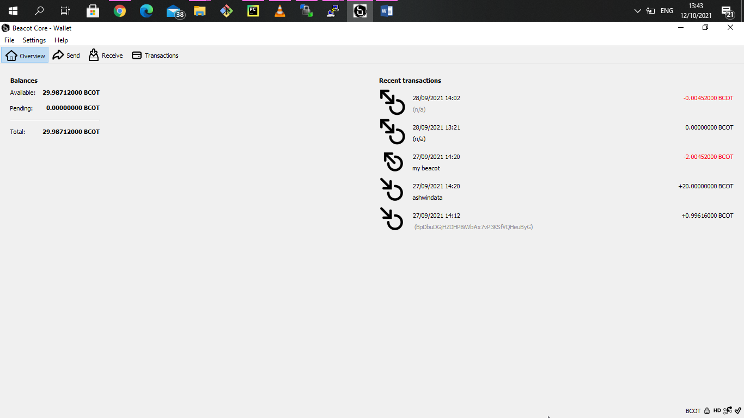

If u open wallet first time your transaction would be empty and balance would be 0.

1. Now click on receive=>Request payment

It will open one window which contain address please copy that by clicking copy address.

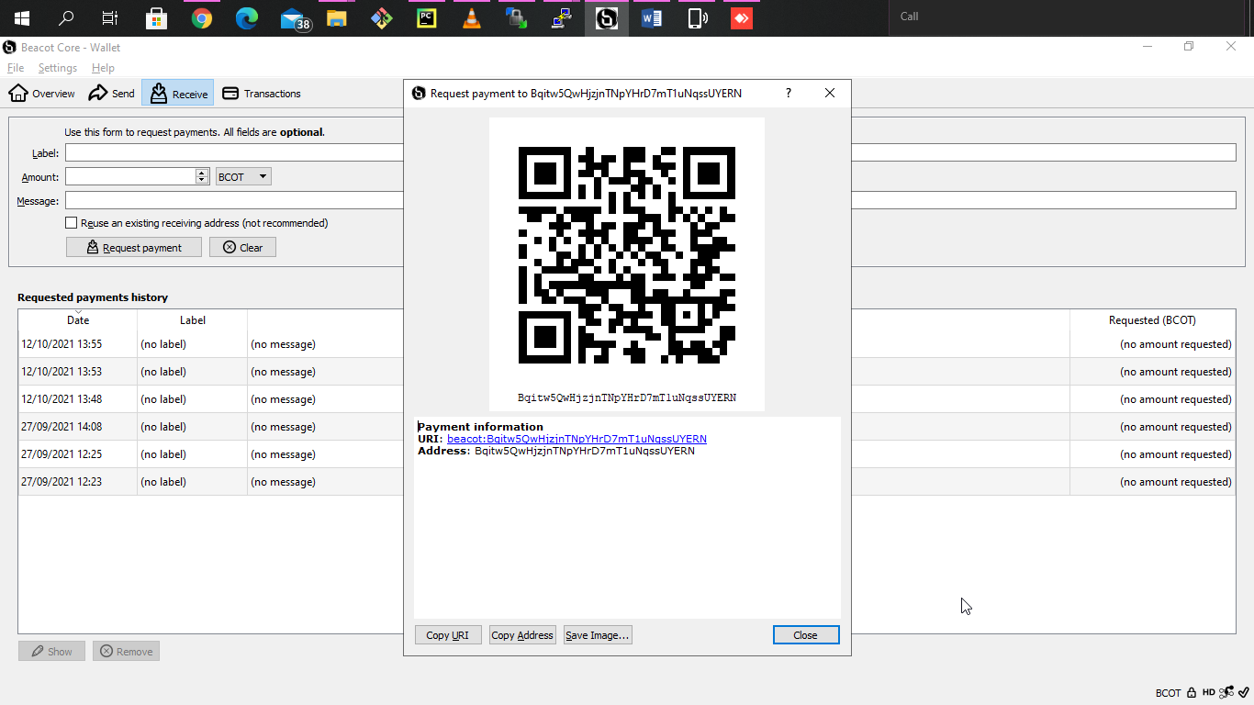

**How to get Private Key from address?**

1. Open your wallet named “beacot-qt.exe”.

Go to transactions and get any transaction which has type “Received with” click on it and copy address

If transaction is empty please create new address

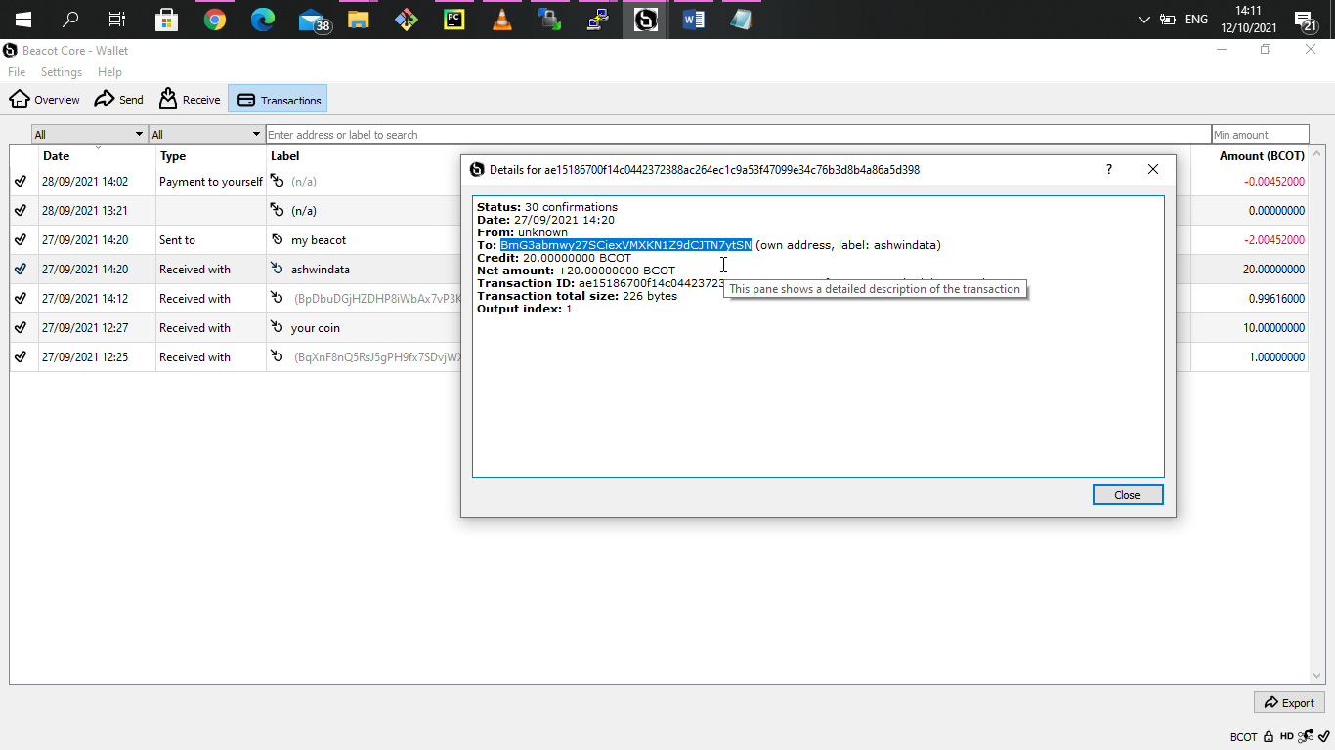

1. Now close that window go to setting choose "Encrypt wallet" and set the passphrase for wallet

If u have already set passphrase skip this step

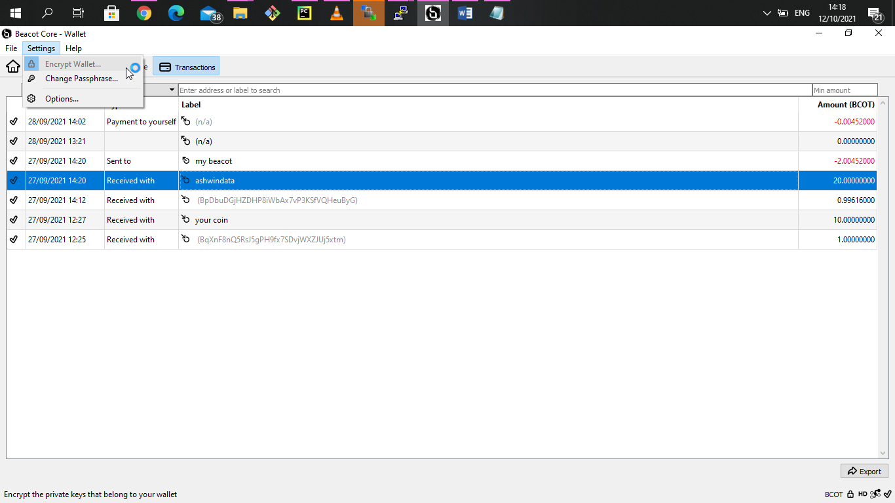

1. Then click on help=>Debug Window=>console

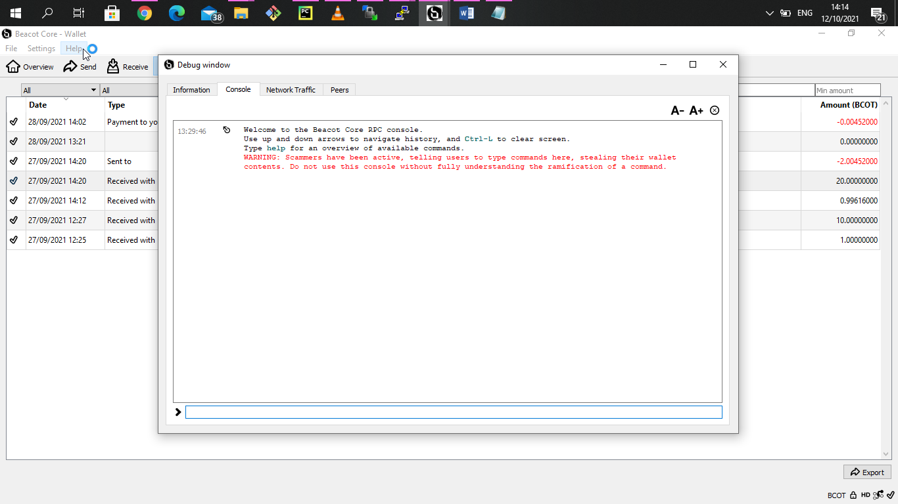

1. Type command at the bottom

walletpassphrase #password_of_wallet 1200

It will just show "null".

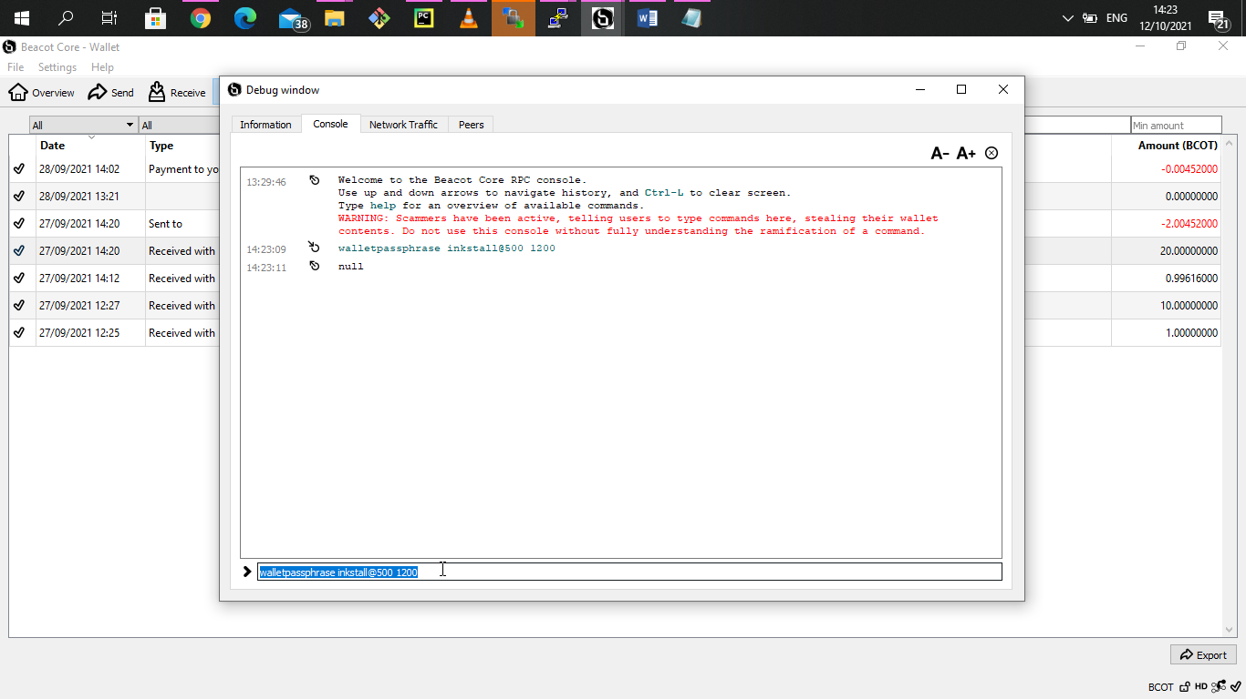

1. now type in console "dumpprivkey #choosen_address"

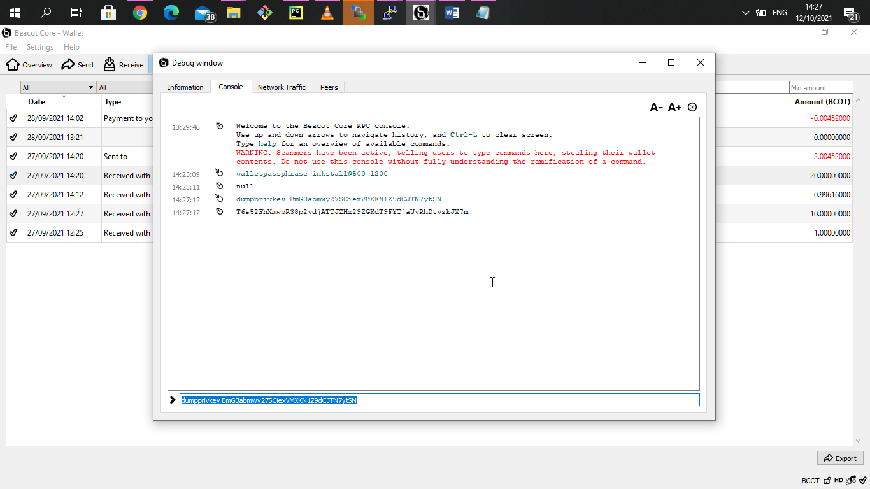

1. So we get private key here save it safely. We can restore that address by using that private key.

**How to restore address and data from private Key?**

1. Open your wallet named “beacot-qt.exe”.

click on help=>Debug Window=>console



1. Type command at the bottom

walletpassphrase #password_of_wallet 1200

It will just show "null".



1. Then run "importprivkey #private_key"

